Android phone:
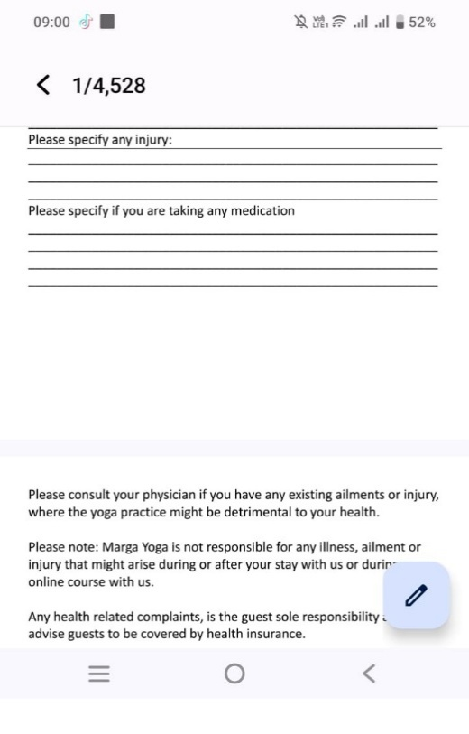
Click on the edit button (blue one) to edit the form
Write on the form with a pen or with your finger.
Save the form.
THE FORM DOESN’T NEED TO BE PRINTED
Please send the form by mail:
simona@marga-yoga-retreats.com or
send the form by WhatsApp: +66808899960
Please confirm your class date and time
Thank you!

IPhone:

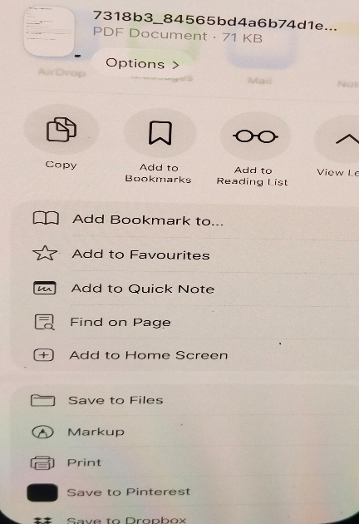
Press “share”
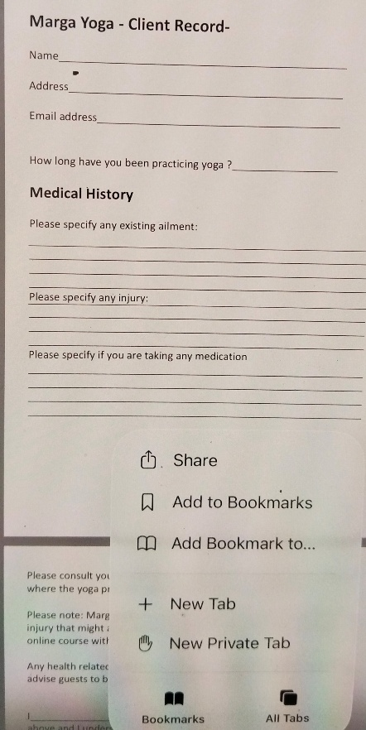
Press “markup”
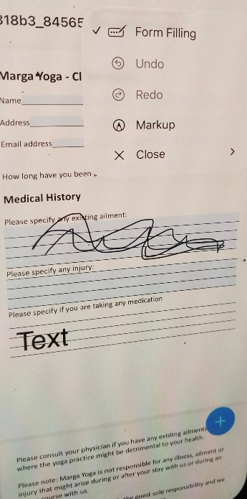
Press “form filling”
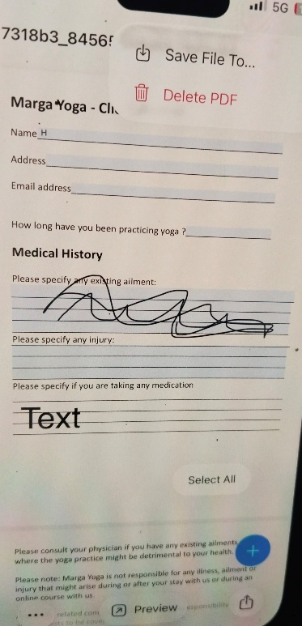
Press the upload button (bottom right) to share it to WhatsApp or mail to the address above (see Android phone)
Or press “save file to” (top right)
Thank you!

